Countdown to DMA implementation

Lasting legacy or missed opportunity?
With the EU Digital Markets Act (DMA) adopted and 2023 well underway, the clock is ticking towards implementation of what has the potential to be a ground-breaking piece of legislation - and the start of a new chapter in genuine competition and digital fairness for small European businesses and consumers alike.
It’s far from a done deal though. Whilst we are hearing that the political will appears to be sound, the devil, as always, will be in the detail. The new, fresh European Commission team, recently recruited to manage implementation, had better be made of strong stuff. It is going to need an iron-clad backbone to withhold the onslaught of the Google lobbying machine and technical wizardry that has so far enabled one of the world’s largest monopolies to wriggle miraculously out of any meaningful changes to its abusive behaviour. Google continues to flagrantly abuse its position, despite losing three antitrust cases and fines totalling 8.25 billion euros. The damaging behaviour continues, despite demands for an end to the market abuse that has stunted the growth of European businesses and let consumers down for more than a decade.
On paper, Google was punished for self-preferencing in the Google Shopping case and ordered by the European Commission to stop its abusive behaviour. The General Court largely dismissed Google’s appeal against the Commission’s decision and confirmed the penalty, with the judgement stating that it “takes into consideration the fact that the conduct in question was adopted intentionally, not negligently.” However, in reality, Google proposed a remedy that has given it an even greater hold on the market - and the abusive behaviour continues.
On paper, the DMA demands an end to self-preferencing by gatekeepers. In reality? We’ll see.

We definitely have skin in the game, but this isn’t just about us; holidays/flights, jobs, local - just some of the other sectors crippled by Google’s self-preferencing and abuse of its market dominance in Search.

Proposed remedy
To date, Europe’s competition authorities have failed to achieve a level playing field. The DMA could change this. Google’s search engine results page in respect of shopping-related queries must be compliant with the DMA’s principles of fair, reasonable, and non-discriminatory (FRAND) conditions of display and ensures FRAND access to online search engines. We need radical, workable changes to the entire online shopping comparison display and auction process - and these cannot come from Google, as we know from experience that it can’t be trusted to mark its own homework.

There is an immediate solution in the form of Comparison Listing Ads (CLAs). They already exist however, they are hidden behind the Product Listings Ad (PLA) carousel by Google - which means they are less visible, less attractive, and less functional. If CLA became the default, then consumers would have access to more products and be able to make great shopping choices once again.

The application of the obligations imposed on Big Tech companies that are designated as gatekeepers will come into force in March 2024. We could be embracing a brave new, more competitive, and fairer world, or we could be stuck on the merry-go-round. So, what can we all do?

We call for action for the sake of companies like ours, for SMEs everywhere trying to compete on a level playing field and for consumers, who deserve a transparent and positive experience when searching online for goods and services. We call on everyone working on compliance of the DMA to dot the i’s and cross the t’s - to guarantee real change that would transform the global digital marketplace. This would be an incredible legacy.

DMA timetable
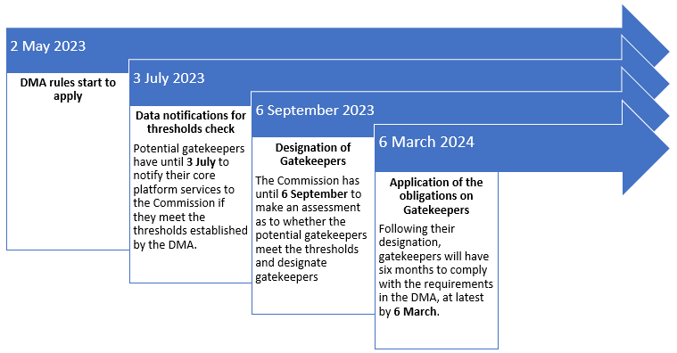

From the General Court judgement: “However, the General Court considers that the Commission did not establish that Google’s conduct had had – even potential – anticompetitive effects on the market for general search services and therefore annuls the finding of an infringement in respect of that market alone.”
Source: https://ec.europa.eu/commission/presscorner/detail/en/qanda_20_2349

