FAQs

Introduction:
Kelkoo Group was a hugely successful comparison-shopping service (CSS) that helped consumers to make great shopping choices and helped online retailers to reach those consumers. However, virtually overnight, Kelkoo was taken to a cliff edge by Google’s self-preferencing behaviour. We are one of the lead complainants in the Google Shopping case in Europe and have been lobbying for fair digital markets since 2011. We are in regular dialogue with global regulators who are keen to end monopolist behaviour and restore competition and consumer choice.

1.0 About self-preferencing:
What is self-preferencing and why is it a problem?
The simplest explanation is that self-preferencing is the practice of online platforms, such as Google, promoting and favouring its services and products and demoting those of competitors. It’s how a platform manages its ecosystem, including decisions at design level on how third-party services and products are treated compared to Google’s own services and products. The fact is that Google’s Product Listing Ads (PLA) is, in effect, a CSS on the Search Engine Results Page (SERP).

How does Google self-preference in practice?
Using its overwhelming dominance in Search, Google promoted its own CSS and excluded competitors like Kelkoo from its general search results through multiple algorithmic changes. As a result, consumers could no longer find Kelkoo or services like ours. Competition in shopping comparison was decimated, leaving consumers poorer and Kelkoo and others struggling for survival. This is self-preferencing in action.

Who is affected by Google’s behaviour?
Google’s self-preferencing and exclusionary practices are not limited to shopping comparison. Its abuse has spread to other verticals like local, flights and hotels. Google is following the same pattern in these verticals that it established in Shopping. Setting an effective precedent against this behaviour is vitally important for all verticals if we are to avoid restriction of consumer choice across the board in the future.
An example of this is Hotels. Online paid-search competition is intensifying, and it is getting more challenging to be visible in organic results for hotel category searches (e.g. hotels in New York). Brands are compelled to buy Hotel Ads to appear anywhere above the fold. Google Hotels offers similar functionality and tools to its competitors - but now appears above the general search results and is given an unfair advantage over rivals who look to be suffering the same fate as CSSs did years earlier. In the long term, this will reduce choice for hotels and travel operators wishing to reach consumers, and as a result drive up consumer prices.
2.0 About the Google Shopping case:
What is the Google Shopping case?
Kelkoo is one of the lead complainants in the Google Shopping case in Europe. In 2017, after a seven-year investigation by the European Commission into Google’s search practices, Google was found guilty of self-preferencing and fined a record €2.4bn for abusing its search engine dominance to crush competitors in shopping price comparison. Google was also ordered to change its abusive behaviour.

What were the Commission’s specific complaints in the Google Shopping case?
The specific complaints issued by the European Commission included:
- Google's search results predominately display Google Shopping results regardless of the merits of how well the Google Shopping results meet the results of the search query
- Google did not apply its system of penalties, a predefined set of parameters to lower the placement of shopping results, to its own Google Shopping results as it did to competitors
- Google had launched a rival comparison shopping service (Froogle) which wasn’t given preferential treatment, and as a result, performed poorly. In contrast, Google Shopping was given favourable placement in Google's search results, allowing the service to achieve higher rates of growth
- Google's favouring of Google Shopping reduced consumer choice and innovation

What was the decision against Google in the Google Shopping Case?
In 2017 the European Commission took a landmark decision to fine Google €2.4bn for abusing its search engine dominance to crush competitors in shopping price comparison. The Commission not only sanctioned Google's conduct by imposing a then-record fine, but it also ordered Google to end its self-preferencing conduct and ensure equal access to all third-party providers on its general search website.

At the heart of the Commission's finding of an abuse of dominance lay the novel theory of harm - namely that Google had designed the results page of “Google Search” in a way that favoured its own CSS - Google Shopping - while placing rival CSS websites at a competitive disadvantage.

Did Google accept the Commission’s decision?
No. Google appealed but the European General Court dismissed Google's action against the decision on 10th November 2021.

On what grounds did the European General Court dismiss Google’s appeal?
Link to the Court press release here
•The General Court recognises the anticompetitive nature of the practice at issue
•The Commission correctly found harmful effects on competition
•The General Court rules out any objective justifications for Google’s conduct
•Following a fresh assessment of the infringement, the General Court confirms the amount of the penalty
Has the decision against Google in the Google Shopping case stopped Google from self-preferencing?
No. Despite Google being fined by the European Commission and ordered to change its abusive behaviour back in 2017, there is now more, not less, abuse of dominance in online shopping by Google.

In what way has the Commission’s decision not changed Google’s self-preferencing behaviour?
Google’s self-created ‘shopping remedy,’ proposed by Google following the decision against it, not only rips even more money out of competitors’ pockets and into its own, but it also deprives consumers of any meaningful change in the services available to them. Since 2017, Google’s market dominance in search, advertising and other online businesses has grown. In fact, Google’s share price and revenue both increased more than 145 percent between 2017 and 2022.

3.0 How to end Google’s self-preferencing:
What is the solution to stop Google promoting its own products and demoting competitors?
It’s a very simple solution - Comparison Listing Ads (CLA). They already exist however, they are hidden behind the Product Listings Ad (PLA) carousel by Google - which means they are less visible, less attractive, and less functional. If CLA became the default, then consumers would have access to more products and be able to make great shopping choices once again.

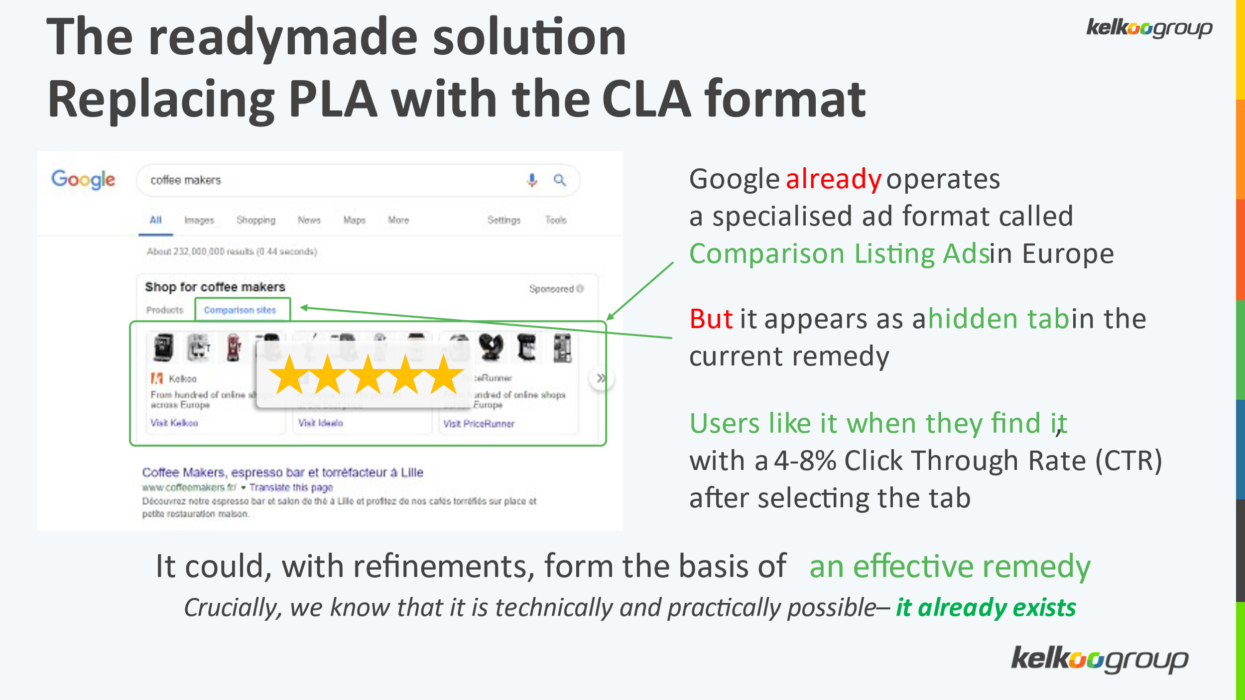

4.0 About the Digital Markets Act:
What is the Digital Markets Act?
Some large online platforms act as "gatekeepers" in digital markets. The Digital Markets Act (DMA) aims to ensure that these platforms cannot abuse their market dominance. Together with the Digital Services Act, the DMA is one of the centrepieces of the European digital strategy and the success of these Regulations will largely define the legacy of this Commission and European Parliament legislature.

Under the DMA, gatekeepers will no longer be able to “treat services and products offered by the gatekeeper itself more favourably in ranking than similar services or products offered by third parties on the gatekeeper's platform.”

The DMA will not supplant competition law. Executive VP Commissioner Vestager has stated clearly the Commission views the DMA as a complement to competition law.

What does Kelkoo want the DMA to fix?
Article 6(5) of the DMA prohibits self-preferencing by gatekeeper platforms. This means that there should be no preferential treatment “in ranking and related indexing and crawling” of first party services and products over third-party services and products. However, we are in the implementation phase, and how this article is interpreted and imposed will make the difference between the unfair status quo and meaningful competition and fairness in online shopping.

Over the past decade, the European Union has pursued three cases against Google and levied €8.25bn in fines and has ordered Google to stop self-preferencing. Unfortunately, Google’s self-created ‘shopping remedy’ not only rips even more money out of competitors’ pockets and puts it into its own, it also deprives consumers of any meaningful change in the services available to them. Google’s market dominance in search, advertising and other online businesses has grown. In fact, Google’s share price and revenue went up more than 145 percent between 2017 and 2022, when the EU fined it €2.42bn for abusive behaviour.
For companies like price comparison shopping business Kelkoo Group, this outcome is commercially crippling. Our market presence has been eroded by Google as we wait years for a regulator to step in with a meaningful solution that will be effectively enforced. The DMA, if implemented properly, could deliver this meaningful solution and would be a lasting legacy for all those working on it in the EU institutions who will be able to claim their role in restoring genuine competition and fairness in online shopping for the benefit of businesses, including SMEs, as well as consumers.
The DMA has been adopted - why is Kelkoo still concerned?
A lot can happen at implementation level. The law must be interpreted. Vested interests who stand to suffer the restrictions imposed by the DMA will be looking for loopholes and Google has a bottomless pit of financial, manpower and technical resources to fight for the status quo which keeps it in charge of the entire ecosystem. We see from the Google Shopping case that, even though Google lost, its abusive self-preferencing behaviour continues. How Article 6(5) is interpreted and imposed will make the difference between continued abuse of dominance by gatekeepers and meaningful competition and fairness in online shopping.

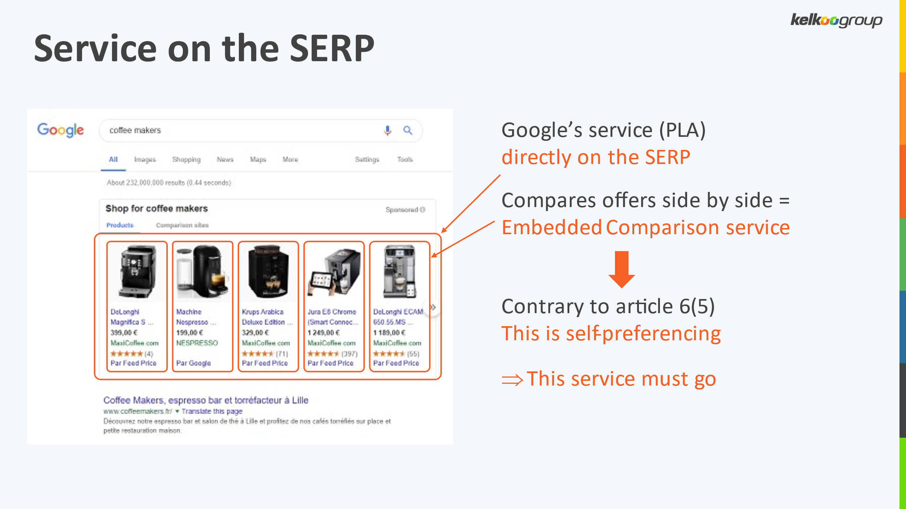

What is the DMA timetable?
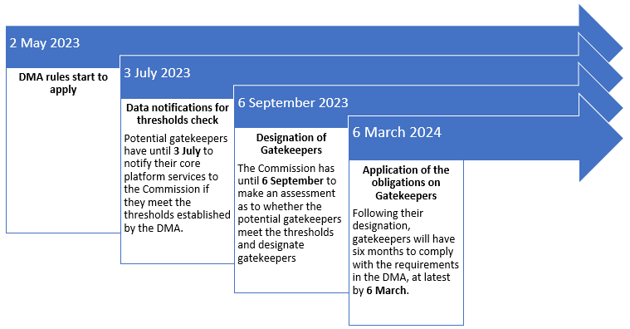

5.0 About Kelkoo Group CEO Richard Stables
As one of the lead complainants in the Google Shopping case, Rich has spoken on topics such as the Google Shopping case, the DMA and related antitrust and competition issues affecting SMEs and consumers, including presentation of Kelkoo’s solution to restore fairness in online shopping. On the European Commission’s request, Rich presented Kelkoo’s solution at the DMA Workshop on self-preferencing in December 2022. He is an accomplished public speaker with passion and integrity and has been asked on numerous panels over the years.

Rich joined Kelkoo Group’s Executive Team in 2009 and, as CEO, leads business development initiatives to support the growth and expansion of Kelkoo Group in 39 countries including Europe and South America. He also oversaw the acquisition of LeGuide Group.

Prior to joining Kelkoo Group in 2009, Rich occupied a variety of positions for companies including uSwitch.com, Stamps.com and Pricewaterhouse Coopers. He holds a PhD in International Relations from the University of Warwick.

6.0 Kelkoo Group and competition cases around the world
Kelkoo Group and CEO Richard Stables are also active in other territories where Google’s dominance in online shopping is under scrutiny, notably in the UK and the US.

https://commission.europa.eu/strategy-and-policy/priorities-2019-2024/europe-fit-digital-age/digital-markets-act-ensuring-fair-and-open-digital-markets_en

